Grade 7 Accelerated · Unit 3 · Lesson 5  Applying Exponent Laws  Question Bank - Additional 3.05 ANSWER KEY | Name  Date  Period

Show your work. Circle your final answer.
For questions 1 through 4, rewrite each expression as an equivalent expression with a positive exponent.
1. 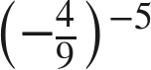
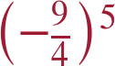

2. 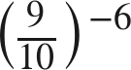
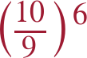

3. 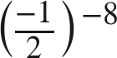

The reciprocal of −1/2 is −2.

4. 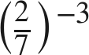
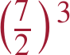

Matching.
5. Match each expression on the left with the equivalent expression on the right by writing the letter.
a. 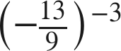 A. 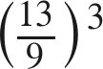 B. 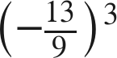 C. 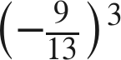 D. 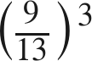
C
b. 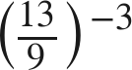
D
c. 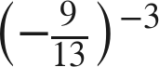
B
d. 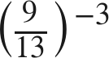
A

For questions 6 through 9, generate an equivalent expression with one base and one positive exponent. Show the laws you use.
6. 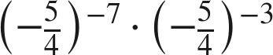
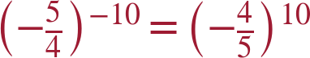

7. 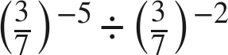
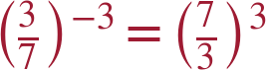
−5 − (−2) = −3, then flip.

8. 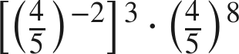
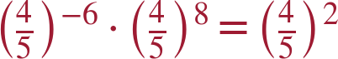

9. 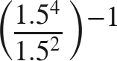
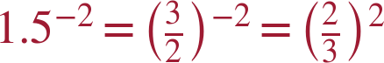

Equivalent or not.
10. Consider the expression 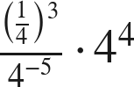. For each expression below, decide whether it is equivalent, and justify with a law of exponents.
a. 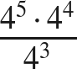
Yes — both simplify to .
b. 
No — this is .
c. 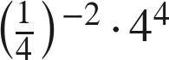
Yes — .
d. 
Yes.

11. Which is the value of 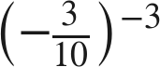 ?
○ A. 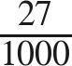
○ B. 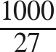
○ C. 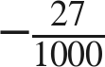
● D. 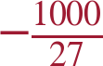
D

12. Find the value of that makes each statement true.
a. 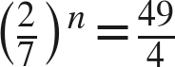
n = −2
b. 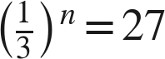
n = −3

